**Science Year 7 2022**

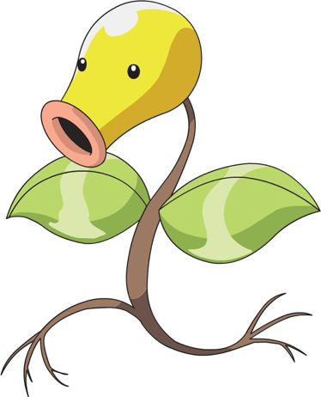**Task 4 – Biokemon Card Validation**

Student Name: ______________________________________________________________

Teacher: ___________________________________________________________________

**Conditions:**

* 45 minutes in class
* Must bring completed Biokemon Card to use in the validation

**Mark Allocation:**

|  |  |
| --- | --- |
| **Part A: Biokemon card**  Handed in on time  All aspects completed  Effort has been put in  Card is aesthetically pleasing  Organism fits in chosen ecosystem | /5 |
| **Part B: Validation** | /25 |
| **Total** | /30 |

**Part B: Validation (25 marks)**

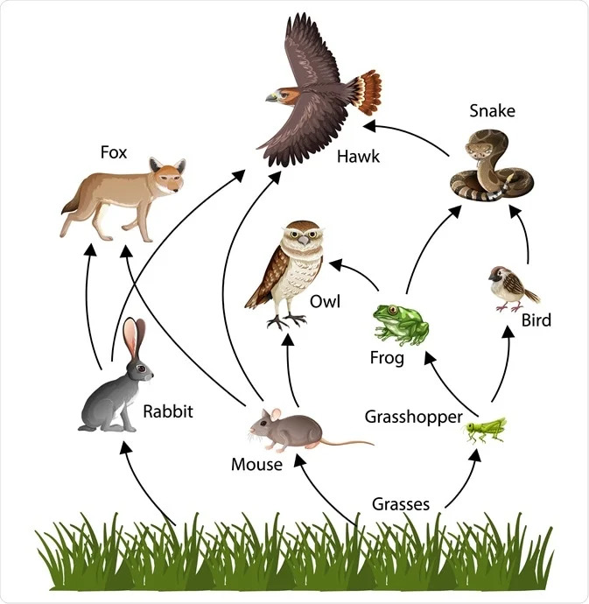**Use the food web below to answer Questions 1-5**

1. Describe what the arrow represents in the food web (1 mark)

________________________________________________________________________________________________________________________________

1. What is the source of all of the energy in the food web? (1 mark)

________________________________________________________________

1. Draw two food chains that occur in the ecosystem. Your food chains should include at least three organisms (four steps) (4 marks)
2. Complete the table to show one organism from the food web for each of the trophic levels and ecosystem roles (4 marks)

|  |  |
| --- | --- |
| **Ecosystem role** | **Organism from food web** |
| Predator |  |
| Secondary consumer |  |
| Primary consumer |  |
| Producer |  |

1. Identify one organism and it’s trophic level (position in the food web) and describe the features of that trophic level. (2 marks)

________________________________________________________________________________________________________________________________________________________________________________________________________________________________________________________________

1. Describe what is meant by native and introduced. Provide examples of each. (3 marks)

________________________________________________________________________________________________________________________________________________________________________________________________________________________________________________________________________________________________________________________________________________________________________________________________________________________________________________________________

1. Match the IUCN conservation status to the meaning using lines (2 marks)

|  |  |  |
| --- | --- | --- |
| Critically endangered |  | Species is considered to be facing a very high risk of extinction |
| Least concern |  | Species is close to being threatened |
| Near threatened |  | Species is considered to be facing an extremely high risk of extinction |
| Endangered |  | Species are not threatened by extinction |

**The rest of the questions relate to your Biokemon card species and the ecosystem your class focussed on.**

1. What is the IUCN conservation rating of your organism? (1 mark)

______________________________

1. Describe why your organism is important to your class’ ecosystem (3 marks)

________________________________________________________________________________________________________________________________________________________________________________________________________________________________________________________________________________________________________________________________

1. Discuss one threat to your ecosystem and what could be done to mitigate (fix) that threat. (4 marks)

________________________________________________________________________________________________________________________________________________________________________________________________________________________________________________________________________________________________________________________________________________________________________________________________________________________________________________________________________________________________________________________________________________________________________________________________________________________________________________________________________________________________________________________________